AUBEA 2024 Conference Paper Template

Paper Title Here (Capitalise All Words and Center Align with Bold Font)

Z. Vrcelj^{a,}*, M. Sandanayake^{b} and Y. Bouras^{c}

ª First affiliation
^{b} Second affiliation
^{c} Third affiliation
Emails: list emails of authors here in order as above separated by commas
*Corresponding author

Abstract:
The abstract of your paper should be written in a single paragraph and be no more than 250 words. Abstracts should give a brief overview of the paper including the background and/or rationale, the research methodology, and the findings from the research. The practical significance of the research findings should be highlighted and a discussion presented on how the research work contributes to knowledge and addresses current gaps in the specific area, field and/or industry.
Keywords:
Up to 5 keywords should be provided in alphabetical order separated by commas

Introduction
The submitted full paper should follow the following formatting requirements;

- All fonts in the full paper must be TIMES NEW ROMAN only. Main text must be written in 12 pt. size.
- The manuscript should be prepared in A4 size using margins as set in this template (2.5 c.m), in portrait orientation, and in single-column format.
- Landscape orientations should be avoided. However, if necessary, tables and figures can be presented in landscape for more effective presentation. Section breaks must be introduced before and after any changed page orientations.
- The full paper must not exceed 10 pages including References section.
The Introduction should offer an overview of the article, along with the background and context of the paper and present a rationale justifying the need for research. This can be accomplished by presenting evidence of existing problems or identified knowledge gaps in a specific area supported by key references. The author should then articulate a clear research agenda, specifying the research aim and objectives to clarify the purpose of the investigation.
Subsequently, the author should provide a general description of how the research has been or will be conducted to satisfy the aim and objectives, i.e., a brief discussion on the research methodology. This should outline the research design, data collection methods, and data analysis employed or to be employed in the research. Additionally, the author(s) should explain the limitations and scope of the research In this section, the significance of the research findings should be outlined, emphasizing the originality and overall contributions of the investigation.

Literature Review
The Harvard system must be adopted for referencing when writing the AUBEA2024 paper using the following style: (Vrcelj, 2022) or (Vrcelj and Sandanayake 2023) or (Vrcelj et al., 2019; Sandanayake et al., 2023). Please notice that for more than two authors, only the surname of the first author appears followed by “et al.” in italic, a comma, one space and then the year of publication. In the case of more than one articles referenced as shown in the above example, a semi colon (;) has to be added in between followed by one space.
The title of the section 2 does not have to be “Literature Review”. It can be other titles that might better represent the content of this section. Alternatively, this section can be merged with the introduction (section 1)
Each word in the section titles should be capitalised.

Nesting Sub-sections
Nesting sub-sections can be added when required by selecting Heading 2 or Heading 3. In order to format the numbering, right-click on the subsection title, choose “Bullets and Numbering”, select “customize” and choose the desired level and start at as appropriate. Nesting sub-sections should not be done in section 1 or the References section.
Sub-section titles should be bolded and be of 12 pt. size.
Each word in the sub-section title should be capitalised.

The level of sub-section nesting
Authors are not advised to use more than three levels of sub-section nesting. Sub-sub-section titles should be italicised and be of 12 pt. size.
Only the first word in the sub-sub-section title should be capitalised.

Research Methodology
The methodology section should clearly outline the chosen approach and/or research design, as well as the methods for data collection and analysis employed or planned for use in the research. It is important that justification be provided to the selection of methodology. Even for papers at early stages of the research program, potential research methodologies can be proposed based on the identified research problems/questions or the type of expected data.

Findings and Discussion
In this section, the author(s) should discuss all the findings emerging from the investigation, even for early stages of research (e.g. literature review studies). Findings from the investigation should be clearly presented followed by an analytical discussion.
When incorporating tables into the paper, the table caption should be numbered and positioned before the table as follows. One space should be added after the table.

Table 1. Caption times new roman font size 11, capitalise first word only
 | Parameter x | Parameter y | Parameter z

Parameter α

Parameter β

Parameter γ

For figures, the figure caption should be numbered and positioned below the figure as follows.
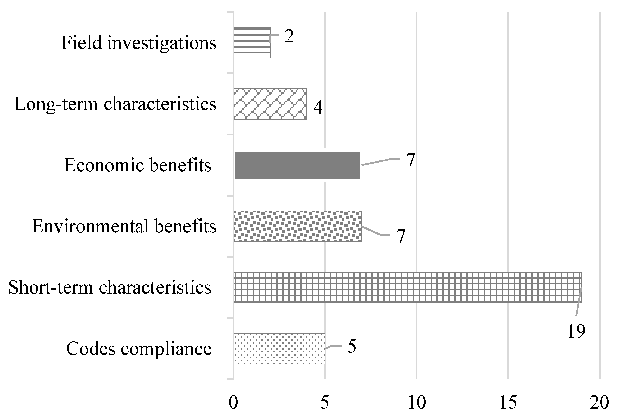
Figure 1. Caption times new roman font size 11, capitalise first word only (Source: Sandanayake et al. 2020)

Any equations are used in the paper should be written using the equation editor (Cambria Math font) and centered in the middle of the page. Equations are numbered in order of appearance in the paper with the equation number placed in brackets and aligned to the far right margin of the page. See the following example;

$a^{2}+b^{2}=c^{2}$ (1)

Conclusion and Further Research
In this section, the author(s) should summarise the entire paper starting with the motivation behind conducting the research, followed by the research aims and objectives, methodological design, findings and the primary findings.
New materials should not be introduced in this section. However, relevant matters that are beyond the current scope of the research should be discussed as well as areas requiring further research. For on-going research, this may include the next stages of the research that will be conducted by the researcher to complete the research.

Acknowledgement
Required acknowledgements should be made here including research funding agencies, contributions of other colleagues and larger research project. If no acknowledgement is necessary, please delete this section from the paper.
This paper template has been adapted from the AUBEA2023 template.

References
Author1, Initials., Author2, Initials. and Author3, Initials. (Year), ‘Article Title’, Journal Title, Volume (issue no.), pp 34-45.
Author1, Initials., Author2, Initials. and Author3, Initials. (Year), Book title, Publisher, Place.
Author1, Initials., Author2, Initials. and Author3, Initials. (Year), ‘Article Title’, In: Editor(s), Book Title, Publisher, Place, pp 34-45.
Author1, Initials., Author2, Initials. and Author3, Initials. (Year), ‘Article Title’, In: Editor(s), Conference Proceeding, Publisher, Place, Dates of Conference, pp 34-45
Author1, Initials., Author2, Initials. and Author3, Initials. (Year), ‘Article Title’, Publication/Publisher, http://www.url_address.co/article1.htm, viewed: 31/12/2017.

MAXIMUM NUMBER OF PAGES FOR THE PAPER IS 10 (TEN).

